A Vendor Management System (VMS) is software that helps a company buy things from outside partners (called vendors) and keep track of everything in one place.
Think of a company like a school. To run the school, the principal needs outside helpers: a company to supply food for the cafeteria, a technician to fix the air conditioners, and a software provider for online classes. A VMS is the digital notebook that records who these helpers are, how much they cost, whether they did a good job, and when to pay them.
How a VMS Works (The 5 Main Steps)
- Finding & Onboarding: The company checks if a new vendor is safe, reliable, and legally allowed to work with them.
- Contracting: Both sides agree on prices, delivery dates, and work rules.
- Ordering Work: The company sends a Purchase Order (PO)—an official order slip—saying exactly what goods or services they want.
- Tracking Work: The company checks if the vendor delivered the goods on time and followed the rules.
- Invoice & Payment: The vendor sends a bill (invoice). The system matches the bill with the original agreement and pays the vendor.
Key Stakeholders (Who Uses It?)
- Procurement Team (The Buyers): Finds vendors and negotiates the best prices.
- Finance Team (The Money Managers): Checks invoices and sends payment.
- Legal & Compliance Team (The Rule Checkers): Makes sure vendors follow local laws, data safety rules, and contracts.
- Department Managers (The Everyday Users): Employees (like Marketing or IT) who actually work with the vendor day-to-day.
- The Vendors (The Outside Partners): The suppliers who log in to upload documents, submit bills, and track payment status.

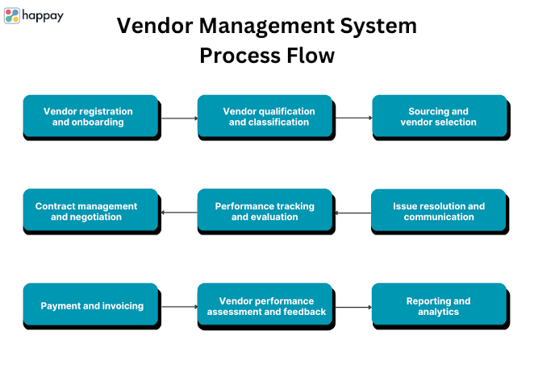
Example: Where the Root Problem Lies
Here is a common scenario showing why vendor management breaks down:
The Story of TechCorp
- A Marketing Director wants a new logo design. Instead of using the company's official system, they email a designer directly, sign a contract via email for $10,000, and tell them to start.
- Three months later, the designer sends an invoice for $15,000 to the Finance team.
- The Breakdown: Finance has no record of this contract. Legal never checked if the designer keeps company files safe. The Marketing Director has already left the company. Finance pays late, the designer gets angry, and TechCorp overpaid by $5,000.
The Root Problem: Software only tracks actions taken inside the system. But humans often negotiate, order, and communicate outside the system using email, Slack, or quick phone calls. This creates Shadow Spending (hidden purchases) and legal risks.

Unresolved Problem | Why It Stays Unresolved
Shadow IT & Hidden Spend | Employees keep buying software subscriptions on personal or company credit cards without telling IT or Procurement.
Static Risk Assessment | A system checks if a vendor is safe on Day 1, but doesn't alert the company if that vendor suffers a data breach on Day 100.
Poor System Integration | The VMS often doesn't talk seamlessly to the bank, HR software, or accounting tools, requiring manual data entry.
Global Friction | Handling 50 different tax laws, foreign currencies, local bank rules, and international labor laws across multiple countries remains chaotic.

Market Players: What They Solve vs. What They Cannot Solve Yet
1. Enterprise Giants (SAP Ariba, Coupa)
- What they solve: Huge scale for Global 2000 companies. They handle millions of dollars in corporate spend, complex purchase approvals, and large global supply chains.
- What they cannot solve yet: They take 6 to 18 months to set up, cost a fortune, and have clunky interfaces. Employees hate using them, so people actively avoid the system.
2. Modern All-in-One Tools (Rippling, Airbase, Aspire)
- What they solve: Fast setup for fast-growing companies. They combine vendor tracking, virtual corporate cards, and automated global payments into one simple dashboard.
- What they cannot solve yet: They lack deep industrial supply chain features (like factory floor auditing or complex raw material manufacturing workflows).
3. Contingent Worker Platforms (Workday VNDLY, SAP Fieldglass)
- What they solve: Managing external freelancers, hourly agency staff, and temporary contractors across regions.
- What they cannot solve yet: They struggle to combine freelance worker management with software subscriptions and physical product purchases in one smooth experience.

ources & Evidence
- Digital Adoption — Vendor Management Challenges: [https://www.digital-adoption.com/vendor-management-challenges/](https://www.digital-adoption.com/vendor-management-challenges/)
- Zycus — Complete Guide to Vendor Management: [https://www.zycus.com/blog/supplier-management/a-complete-guide-to-vendor-management-its-benefits-challenges-process-best-practices](https://www.zycus.com/blog/supplier-management/a-complete-guide-to-vendor-management-its-benefits-challenges-process-best-practices)
- Rippling — Best Vendor Management Systems (2026): [https://www.rippling.com/blog/vendor-management-systems](https://www.rippling.com/blog/vendor-management-systems)
- MESH Works — Top Vendor Management Software Comparison: [https://www.meshworks.com/blog/the-best-vendor-management-software-for-industrial-and-manufacturing-teams-2026](https://www.meshworks.com/blog/the-best-vendor-management-software-for-industrial-and-manufacturing-teams-2026)
- TechnologyMatch — Top IT Vendor Management Challenges: [https://technologymatch.com/blog/top-it-vendor-management-challenges-in-2025-and-how-to-solve-them](https://technologymatch.com/blog/top-it-vendor-management-challenges-in-2025-and-how-to-solve-them)

